Design a housing estate

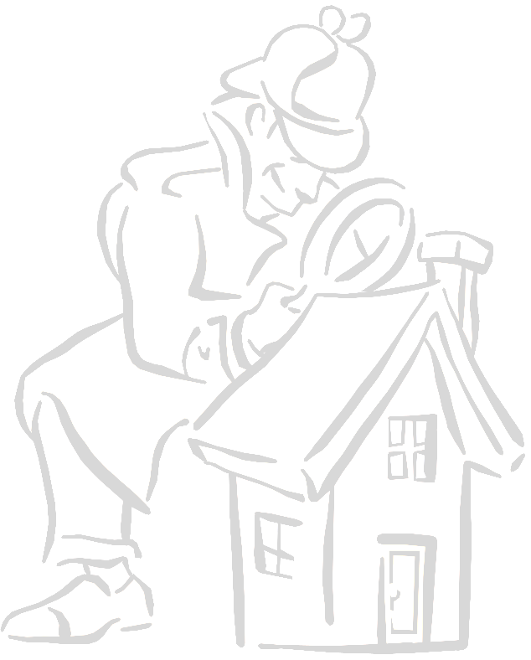
Houses are made by cutting out the templates and folding along the black lines. Cut along the arrows to make slots. Create the house by sliding the slots together. Between 6 and 9 houses could fit on a sheet of A4 paper.

The constraints can very simple e.g. none –use plain A4 paper or can be increased by using the sites included in this document.

Further complications can be created by restricting the changes that can be made to the sites e.g. half the trees must be retained. Cost considerations can also be included as terraced or semi-detached houses are cheaper than detached ones. Space must be allowed for vehicles including dustbin lorries. Children also enjoy drawing other facilities e.g. playgrounds, bus stops on the sites. Even more complicated constraints can be imposed with older participants e.g. all gardens must be south facing.

All of the suggested sites can be amended using Word.

I have used this with Y2 –Y6 and my wife has used it with adults.

This exercise is not my own but is based on an exercise I was given when I completed a Diploma in Environmental Education in 1985.

This activity could be used in QCA Geography units 9,13,16 or 21 or in work to satisfy PSHE & Citizenship at KS2 1a,2a,2d,2f,2j,2k,4a,5g and at KS1 1a,1b,2a,2b,2e,2g,2d,4a,4b

Design a housing estate

Houses are made by cutting out the templates and folding along the black lines. Cut along the arrows to make slots. Create the house by sliding the slots together.

H
E
D
G
E

H
E
D
G
E

H
E
D
G
E

