Your body needs
fruit and vegetables!

Try to eat 5 portions of fruit or vegetables every day!
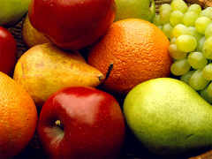
Fruit and veg help your body to grow strong and healthy.


