Your body needs Water!

Remember to bring your water bottle to school every day!
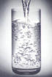
Water helps your brain to work better.
