Mezuzah
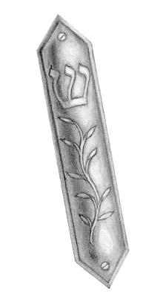
The first thing that a Jewish family will do when they move into a new home is to put up their mezuzot. A mezuzah is a small box or tube that is fixed to the doorframe of each door in the house. Mezuzot can be all sorts of shapes, sizes or materials. Here is a picture of one. Can you see the two little screws that hold it to the doorpost?


Can you see the symbol on it that looks like a crown with three spikes? It is a letter from the Hebrew alphabet. The letter is called shin and is the first letter of the Hebrew word Shaddai, which means Lord. Many mezuzot have the letter shin on them as a decoration. Some have the whole word, Shaddai written on them.
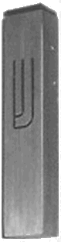
And here is another mezuzah.
It has a shin on it, too.

Inside each mezuzah is a little parchment scroll with the words of part of the Shema written on it in tiny Hebrew writing. They must be written by hand. In the Shema it says “Write them on the doorposts of your home”. (“Them” means the words of Torah). This is why Jewish people put mezuzot on their doorframes.

The mezuzah is fixed to the doorframe on the right hand side as you go into the house or room. The mezuzah must be fixed at an angle so that the top is nearest to the room. Jews who are very religious will kiss the fingers of their right hand and then touch the mezuzah whenever they go into a room.

Tallit
(Pronounced “tulleet”)

A tallit is a prayer shawl. It is a rectangle of woven cloth, usually wool or silk (but never both). A tallit is usually decorated with several blue or black stripes at each end. The two ends will also end in fringes or a series of knots. Tied through a small hole in each corner is a longer group of threads called a tzitzit. The tzitzit are actually the really important bit. They are there because the Shema tells people to wear fringes on the corners of their clothes. Most tallitot have a thicker piece of material sewn on to form a sort of collar, which is often decorated with patterns or with the words of the blessing that people say as they put the tallit on. When we want to talk about more than one tallit, we call them tallitot.

Jewish people wear tallitot during morning prayers, and especially when they are reading the Torah or hearing it read.

There are many different customs about who should wear a tallit. In many communities only men wear a tallit but in others both men and women will wear them. In many Jewish communities only people over the age of 13 wear tallitot. In others only people who are married will wear them.

Some people will wear their tallit like a shawl, wrapped around their shoulders, some will wear it around their shoulders, like a cloak and others wear a tallit draped around their neck rather like a scarf, with one end hanging down on each side.

Tefillin
(You say t’fill’in)

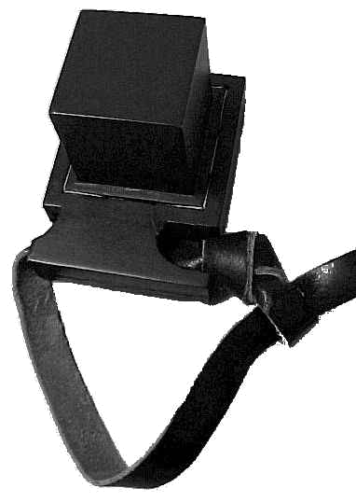
When Jews say their morning prayers they follow the Shema’s instructions to “Hold fast to them as a sign upon your hand, and let them be as reminders before your eyes.” While they are praying they wear 2 special leather boxes called tefillin. Each box has 4 prayers - the 3 paragraphs of the Shema and another paragraph from the bible which has the same theme - written inside.

One box is strapped onto the left arm (the one on the side nearest the heart). Its straps are wound around the arm and hand so that it makes the shape of the Hebrew letter shin on the back of the hand. The other box is worn on the head so that it is resting on the person’s forehead. These boxes are called TEFILLIN.

The 2 boxes are slightly different. The box for the arm has the prayers written on a single scroll of parchment. The one for the head has them written on 4 separate pieces of parchment. Each prayer has its own compartment in the box. The box for the arm has one long strap. The box for the head has two straps which are meant to hang down in front of the man’s shoulders, one on each side.

Teachers’ Notes

Mezuzot are not usually put on the doors to lavatories and bathrooms.

Pious Jews will have the scroll inside a mezuzah checked by a scribe every 3 years to check that it is still clearly readable. If it is not, it is no longer kosher and must be replaced. Less pious Jews will be less concerned to have their mezuzot checked. They may even be willing to have a printed-on-paper scroll rather than the strictly kosher handwritten parchment.

There is a tradition amongst Ashkenazi Jews that one should never open a mezuzah. Hence the joke of the man who just couldn’t resist looking inside one of his mezuzot and found a scroll inscribed, not with the Shema, but with the words “Help! I am a prisoner in a mezuzah factory”.

Legend has it that mezuzot are fixed at an angle as a compromise between those who thought they should be horizontal and those who thought they should be vertical.

Tallitot come in a variety of sizes from long and thin (say 36” X 9”) up to 6 feet or more square. There is no significance to the size, nor to the colour. Traditionally Tallitot were plain white with either blue or black stripes but it has become quite common to see people, especially women in progressive communities, wearing brightly coloured tallitot. In Torah it says that one of the threads in each tzitzit should be coloured blue. The blue dye for this was extracted from a particular kind of shellfish, but since certain knowledge of the shellfish’s identity has been lost modern day threads are all white.

The most common time to acquire a tallit is at the time of Bar Mitzvah or Bat Mitzvah, the ceremony which marks the time when a boy or girl of 13 takes on responsibility for his or her own religious development and observance. Many people will replace their tallit when they marry, or when their own children reach bar/bat mitzvah. It is quite common for a person’s tallit to be used as their shroud when they die.

Tefillin are sometimes known by the Greek word phylacteries. Wearing tefillin for morning prayer is known as “laying tefillin” and is a men only activity. Women are specifically excused the need to lay tefillin. Tefillin are not laid on Shabbat or on festivals, since their function is to remind the wearer about Torah and on Shabbat and on festivals this is not thought necessary – the day itself is enough reminder. There are some groups of Jews who do not use tefillin, considering that they are a misinterpretation of the demands of Torah.

The word tefillin is related to the word tefillah, which means prayer.

Left handed people will put their hand tefillin on the right arm.

