Science revision Booklet.

Contents.
Earth and Space.
Magnetism.
Separating materials.
Changing materials.
Forces.
Light.
Materials and their properties.
Sound.
The Body.
Plants.
Electricity.
Animals.
Habitats.
Our senses.
All living things.

How to use this revision guide.
We learn in many different ways and not all ways will suit us. We can use many of our senses to help us learn.
- Ask someone to read this to you if you learn best by hearing something.
- Copy it out, some of us need to write things down to remember them.
- Make posters for each of the areas to make links between the ideas if you learn best by knowing how ideas fit together.
- Read it aloud to yourself, you may learn best by saying things aloud.
- Explain each section to another person, It helps to fix our ideas if we can explain something to someone else.
- Write down the title of each section and write as any facts as you know about that title, then check that you have included everything that is written about it here, anything you don’t have written down you need to revise.
- Amaze your friends and relatives by telling them how much you know.
- Make small books on each subject, I will give you paper and card for books.

1. Earth and space:

- It takes the earth 24 hours to spin once on its axis.
There are 24 hours in a day.
- It takes the Earth 365 ¼ days to orbit the Sun.
There are 365 ¼ days in a year.
- There are 28 days in a Lunar month.
From one full moon to the next.
- The Earth Orbits the Sun in an anticlockwise direction
- The moon orbits the Earth in an anticlockwise direction.
- The earth spins on its axis in a clockwise direction.
- There are 9 planets in the solar system, Mercury, Venus, Earth, Mars, Jupiter, Saturn, Uranus, Neptune, Pluto.
- When the Sun shines on one side of the Earth, it is dark on the opposite side of the Earth.
- The Sun is our closest star.

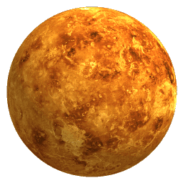

The nine planets in our solar system can be remembered by using the mnemonic;

My Very Easy Method Just Speeds Up Naming Planets
Mercury, Venus, Earth, Mars, Jupiter, Saturn, Uranus, Neptune, Pluto

2. Magnetism.

- Magnets have two ends called poles.
- When you put two poles the same together the magnets repel.
- When you put two different poles together the magnets attract.
- Iron, steel, Nickel and Cobalt are the only magnetic metals.
- Anything that has these metals in it will be attracted to a magnet.
- Magnets have a magnetic field around them.
- The magnetic field is strongest at the ends.
- You can test the strength of magnets by counting how many paper clips you can pick up with them, the magnet that holds the most paper clips is the strongest magnet.

S

N

N

N
These magnets attract.

S

S

S

N

These magnets repel

3. Separating materials.

- To get water out of a solution you evaporate it.
- The hotter it is the quicker water will evaporate.
- To get water back from a solution, first to evaporate the water and then you condense the vapour on something cool.
- To separate solids of different sized dry particles you sieve.
- To separate an insoluble solid from a liquid you filter it.
- To separate an insoluble solid from a soluble solid of similar sized particles you mix them with water and filter the insoluble solid out and then evaporate the solution to get the soluble solid back.
- To separate a mixture of Iron filings from another solid, you can use a magnet. The magnet will attract the iron and leave the other solid behind.
Clouds are made from water vapour. When they condense we get rain.
Water vapour is a gas.
Rain is a liquid.
Ice is a solid
Heat from the Sun evaporates water.

4. Changing materials.

- If two or more things are mixed together and no reaction occurs then the change is reversible.
- Changes that are irreversible are ones where two or more things are mixed together and a reaction does occur.
- Reactions are:
- Bubbling, gas is given off. Mixing bicarbonate of soda with vinegar.
- Heat is given off. Mixing plaster of Paris with water. Energy given off. (Exothermic reaction)
- Heat is applied, cooking an egg. Heat is taken in.

Some things can be melted to change their state from solid to liquid, this is not the same as burning. Chocolate can be melted by applying gentle heat. When you cool it down again it goes back to a solid that is the same as you had before. However, if you burn chocolate, first it melts and then it gives off carbon dioxide gas and water vapour. You can’t put these back into the chocolate so when you cool it you haven’t got what you started with. If you haven’t got what you started with then the change is irreversible. Watch out for questions that say BURN and MELT as the two things are very different.

- Materials come in 3 forms, solid, liquid and gas.
- Solids Do not flow and keep their own shape. Cannot be squashed. Examples of solids include, wood, iron, bricks.
- Liquids Flow easily and take on the shape of the container holding them. Cannot easily be squashed into a smaller volume. Examples of liquids include, water, orange juice, tomato ketchup.
- Gasses flow easily and do not have a shape. Can easily be squashed into a much smaller volume. Examples of gasses include, air, oxygen, carbon dioxide, nitrogen.
Solid  Particles are closely packed together. No spaces between. | Liquid  Particles are spaced out more but still touching. | Gas  Particles are widely spaces and not touching.

5. Forces

- There are two types of force, they are Pushes and Pulls.
- Gravity is a pulling force, it pulls us towards the centre of the Earth.
- Upthrust is a pushing force, it pushes us away from the centre of the Earth.
- Friction is a pulling force, it has the effect of slowing things down. The more friction there is, the slower things go. The less friction there is the faster things go. Rough surfaces have a lot of friction, smooth surfaces have little friction. You move quicker and further on ice than you do on sand.
- Air resistance is a pushing force, it pushes in the opposite direction to whatever is moving.
- Magnetism is a force, magnets will pull magnetic objects and will push away a magnet where the poles are the same.
- Forces are measured in Newtons using a forcemeter.

Direction of travel Gravity

Air
Resistance

Friction

Upthrust

Friction is where two surfaces are touching. In this picture the car tyres and the road surface are touching. Air resistance is pushing against the car in the opposite direction and gravity is pushing the car down.
Up thrust is pushing against gravity

6. Light.

- Light travels in straight lines.
- Light can be split into 7 colours, Red, Orange, Yellow, Green, Blue, Indigo, Violet. These colours are called the visible spectrum and they are the colours of the rainbow. Red is the colour at the top of the rainbow.
- Light travels from a source to an object and then reflects off the object and into our eyes.
- If there is no light we can’t see anything.
- There are primary light sources and secondary light sources. Primary light sources are natural and give out their own light they include, the Sun, Stars and Lightening. The Moon is not a primary light source it does not give out light it reflects light from the Sun. Secondary light sources include light bulbs, televisions, computers etc, something you plug in to give you light.
- Because light travels in straight lines we cannot see round corners however as we can reflect light using shiny surfaces we can use mirrors to see round corners. Periscopes!! Hairdressers using mirrors to see the back of your head!
- We use our eyes to see things. The eye is a spherical object is has a pupil, the dark hole in the middle. The Iris, the coloured part of the eye and the sclera, the white part of the eye. The image of the object we can see is projected onto the inside of the eye, the retina, this image is then sent along the optic nerve to the brain.
- When a light source is blocked by an object a shadow is formed.
- The closer an object is held to a light source the larger the shadow is.
- The further an object is from a light source the smaller the shadow is.
- The more overhead a light source is the shorter the shadow is.
Light bulbs emit light because electricity runs through the filament (the wire inside it,) and this gets very hot and glows. If too much electricity goes through then the filament melts and breaks the circuit.

7. Materials and their properties

- Any material that lets a lot of light through is called transparent. (Glass)
- Any material that lets some light through is called translucent. (Tracing Paper)
- Any material that lets no light through is called opaque. (A brick wall)
- Metals conduct electricity. (Allow electricity to pass through them)
- Plastic is an electrical insulator. (Does not allow electricity to pass through)
- Some metals are magnetic (See magnetism)
- Metals are malleable, they can be moulded into shape.
- Flint is hard.
- Materials that allow water to soak into them are Permeable.
- Materials that will not allow water to soak in are called impermeable.
- Glass is brittle it will break easily
- As well as electrical conductors and insulators, there are thermal conductors and insulators. When we use a saucepan we don’t want to burn our hands on them so we make the handles out of materials that won’t get hot so quickly like wood or plastic. (Thermal Insulators don’t allow heat to pass through them easily) We want the food in the saucepan to get hot quickly so we make the saucepan out of metal, which is a good conductor of heat, it allows heat to pass through it easily. (Thermal conductors, allow heat to pass through them quickly)

Transparent | Translucent | Opaque
Glass for windows because we want to see out of them. | Frosted glass for bathroom windows because we want our bathrooms to be light but we don’t want people to see us in the bath. | Bricks do not allow any light through them so peoples can’t see through our walls, When you shine a light on these they form shadows.
Malleable | Brittle | Sonorous
Steel can easily be shaped into cans. Anything that has been moulded into shape is malleable. | Glass is quite strong but breaks easily, we use this property for fire alarms. Break the glass!!! You wouldn’t make a hammer out of glass would you? | We use metals to make bells because they have a ringing sound, this is what sonorous means, makes a bell like sound.

8. Sound.

- Sound travels in all directions.
- Sound travels in waves.
- Sound is made from vibrations.
- Sound can be reflected, we call this an echo.
- Sounds get louder as they closer and then fainter as they get further away.
- Sounds travel to our ears.
- The sound is directed to our ear drum
- Inside the ear are 3 small bones called the Hammer, Anvil and the Stirrup.
- The sound is then carried to the cochlea and then through the Aural nerve to the brain.
- If vibrations are big we get a low note, if vibrations are small we get a high note.

What’s the difference between a noise and music?
Whether we find it annoying.
Some people like Slipknot, others like S Club seven, others like classical music. If you don’t like these they can seem like a noise.

9. The Body.

- The Circulatory system is the system in the body that is to do with blood. Blood is pumped around the body by the heart. The blood carries oxygen around the body. Blood is taken to the lungs to get it oxygenated and to take the carbon dioxide out. Blood carries oxygen around the body and removes waste products. Veins bring blood to the heart. Arteries carry blood away from the heart. We measure our heart rate by measuring our pulse. Our pulse increases during exercise and decreases after exercise. We measure our pulse rate in beats per minute.

- The Respiratory system is the system that is to do with breathing. Air is taken into your body and taken to the lungs. In the lungs oxygen is taken out of the air and is exchanged for the waste carbon dioxide from the blood. The major organ to do with the respiratory system are the lungs.

- The Digestive system is the system to do with eating. Food is taken into our bodies through the mouth, it travels down the oesophagus (Food pipe) to the stomach. In the stomach the food is mixed with acids and enzymes to form chine. It then passes through the small intestines and then the large intestines. In the intestines most of the water and nutrients are taken out of the food and taken to the organs.
When as much water and nutrients are taken out as possible then what is left is passed out of the body through the anus. (You do a poo!) To get the food into our bodies it has to go into our mouths where it is first processed by our teeth. There are four types of teeth; Incisors, cut food into chunks, Canines, pull tear or rip food, Premolars, chew and grind food and Molars which chew and grind food.

- The Skeletal system is the system in the body to do with bones. Bones give us a hard framework that protects our internal organs. They give us our shape. They provide a structure to attach our muscles to. Without a skeleton we would be a blob, we would have no particular shape, we would not be able to move easily
- Bones are connected in 3 ways.
- Hinge joints like the elbow and the knee.
- Ball and socket joints like the hips and shoulder.
- Sliding joints like the backbone.
9. The Body continued

- Bones are pulled by muscles which contract and relax.

- The Nervous system is the system to do with our actions and thoughts. The major organ to do with the nervous system is the brain, this controls all of our movements and everything else we do. The brain is connected to the spinal chord. This runs down the centre of our backbones and is protected by our backbones. Smaller nerves are located all over our bodies and allow us to feel pain.

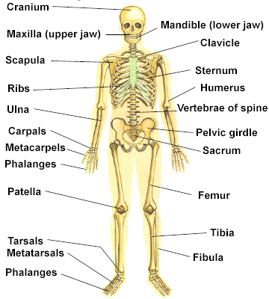

We have the most amazing bodies and we should do all we can to keep them strong and healthy. Take regular exercise, eat the right amount of food, not take drugs or smoke and have regular check-ups with the dentist. If you don’t look after your body, don’t expect it to last for long!!

10. Plants.

- Plants have leaves, flowers, stem, roots.
- Leaves: are for photosynthesis and transpiration.
- Photosynthesis is the process of plants making their own food using sunlight.
- Transpiration is the name we give to the process of plants giving off water vapour.
- Flowers are for attracting bees and other insects to pollinate the plant.
- Pollination is the way that plants reproduce. This process involves the Stigma and the stamen.
- Stigma is the female part of the reproductive system of a flower.
- Stamen is the male part of the reproductive system of a flower.
- Stem. The stem of a plant is the transport system of a plant. Water and nutrients are carried around a plant using the stem. It also holds the plant upright.
- Roots. Roots take in water and nutrients from the soil. They anchor
the plant in the soil.
- To grow a seed has to Germinate. To germinate a plant needs water and warmth.
- For a plant to grow it needs water, air, light and nutrients.

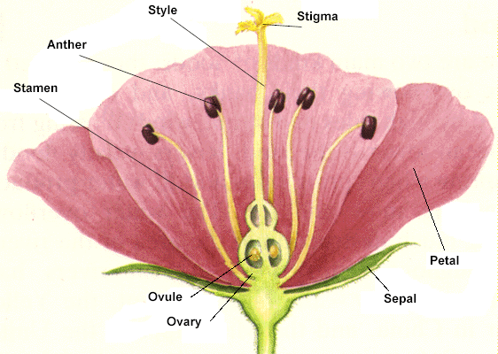

- Electricity.

- Electricity is used to power many appliances in our school and homes.
- Electricity can be stored in batteries.
- Electricity comes into buildings and homes through the mains.
- Mains electricity is dangerous
- Anything that allows electricity to pass through it is called an electrical conductor.
- All metals are electrical conductors.
- Anything that does not allow electricity to pass through it is called an electrical insulator.
- Electrical insulators include; plastics, rubber, wood and glass.
- Electricity makes things work if you connect them up properly.
- To make something work you must have a complete circuit.
- You can make circuits in series or in parallel.
- If you make a series circuit and put bulbs into it, the more bulbs you put in the circuit, the dimmer they will get.
- If you put the same number of bulbs in a parallel circuit they will remain as bright as 1 bulb in the circuit.
- If you make a circuit with a bulb in it and you add more batteries to the circuit, the bulb will get brighter and eventually blow.
- The longer the wire is in a simple circuit the dimmer the bulb will be.

A bulb | A cell | A battery | A switch (open)

The wire is the black line that joins the components in a circuit together, the components are the bulbs, batteries and switches.

This is a circuit diagram. The bulb will not light because the switch is open

- Animal World.

- All the animals on our planet can be divided into two groups, vertebrates and invertebrates.
- Vertebrates are animals with a backbone.
- Invertebrates are animals without a backbone.
- The Vertebrates can be divided into 5 major groups, Mammals, Fish, Birds, Reptiles and Amphibians.
- Mammals, are warm-blooded, they have fur, give birth to live young, feed their young with milk. Examples of mammals, Human, monkey, cat,whale.
- Fish are cold blooded, live in water, they have gills, they have scales, they lay eggs. Examples of fish, Cod, Shark, Perch.
- Birds are warm-blooded, have feathers, have wings, lay eggs, most can fly. Examples of birds, Sparrow, Eagle, Parrot.
- Amphibians lay eggs in water, they are cold blooded, most start their lives in water, they can live in the water or on land. They lay their eggs in water. Examples of amphibians, Frog, toad.
- Reptiles are cold blooded animals, they live on the land and in the sea. Reptiles lay eggs on dry land. Examples of reptiles, Snake, turtle, crocodile
- Some animals only eat plants these are called Herbivores.
- Some animals eat plants and animals, these are called Omnivores.
- Some animals eat only meat, these are called Carnivores.
- All animals are Consumers, consume means to eat, all animals eat so all of them are consumers.
- Some animals eat other animals, these are called Predators.
- Some animals are eaten by other animals, these are called Prey.
- Any animal that eats a plant is a consumer and the plants they eat are called Producers. Producers are the first food in a food chain.
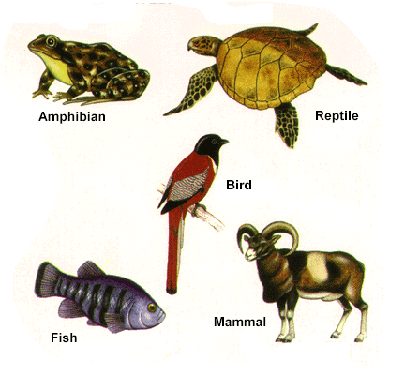

- Habitats.

- Where an animal or plant lives is called its habitat.
- Animals and plants are suited to their habitats in many ways.
- Fish are suited to their environment because they can take in oxygen from the water through their gills.
- A cactus is suited to its desert environment because it has small leaves like needles to reduce the amount of water vapour given of.
- A camel is suited to a desert environment because it has humps to store food as fat for long journeys, it is sand coloured to be camouflaged, it has long eyelashes to keep the sand out of its eyes, it can close its nostrils to keep sand out.
- Birds are suited to a treetop environment because they can escape predators by being at the tops of trees and they can fly to reach the top of a tree.

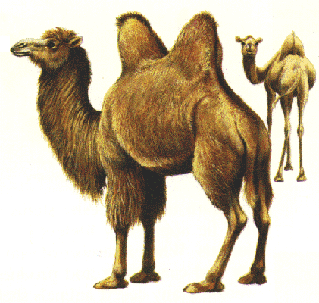

14. Our senses.

- We have 5 senses, they are hearing, sight, touch, taste and smell.
- Hearing is what we do with our ears. Not only can we tell the differences between sounds but we can tell where they come from.
- Sight is the sense that allows us to see things. The major organ we use for sight is our eye. We have two eyes so that we can tell how far things are away from us as well as what they are.
- Touch is the sense we use to feel with. We use our skin and nerves. Our sense of touch not only tells us what things are but warns us against touching things that are too hot or sharp.
- Taste is the sense we use to tell the difference between something sweet or sour, bitter or salty. We use our tongue to taste with. There are different areas of our tongues that sense different tastes.
- Smell is our strongest sense, we can tell the difference between a rose and an onion. We use our noses to smell with. Our noses also filter dust and other things that we breathe in.
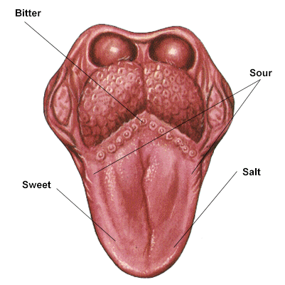
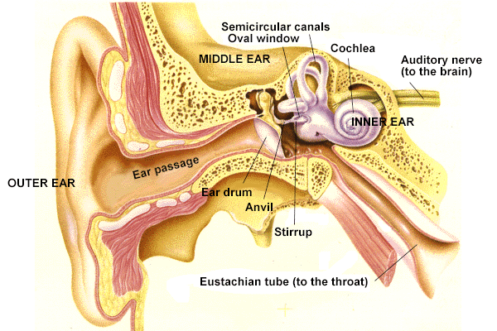
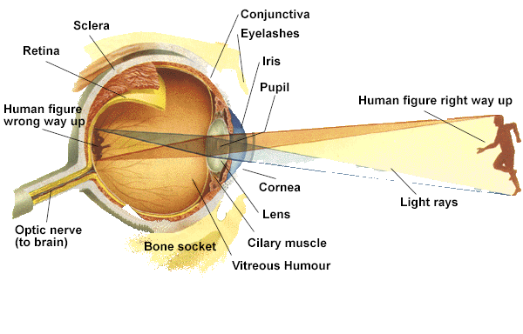

15. All living things.

- All living things have seven things in common.
- Movement. All living things move, we walk, snails slide, worms wriggle, plants move towards the sun. Plants do not have independent movement because they are anchored to one place by their roots, but they can move to face the sun.
- Respiration this is the word we give to breathing. Plants breathe, they take in carbon dioxide and give out Oxygen, we breathe in Oxygen and give out carbon dioxide. It is an exchange of gasses.
- Sensitivity We are all sensitive, we use our senses and respond to what they tell us. If you touch something hot your senses tell you that it will burn you so you take your hand away. If you hear an unfamiliar sound you will turn to look where it came from. Plants respond to the sun, they turn to face the sun, watch a sunflower over the course of a day.
- Nutrition This is getting food or eating, all animals eat, plants make their own food using sunlight.
- Excretion This is getting rid of waste products, when our bodies have finished taking all the goodness out of food we get rid of the waste, we go to the toilet. The waste products for plants are water and Oxygen
- Reproduction. All living things reproduce, They do this to ensure that their species survives. Your parent’s reproduced you. Cats and dogs reproduce kittens and puppies, plants produce seeds that germinate and grow into new plants.
- Growth All living things grow, Some things grow a lot like the giant redwood tree and other things grow a little bit, like ants.

Using these definitions can you tell something that is or has ever been alive from something that has never been alive? Remember that to be a living thing you must do all of these things, of course we may do other things like play, cry, have friends etc but ALL life does the 7 things above.

Humans are alive. You are human so you are alive. Humans are very clever. So are you, especially if you learn all of this. Good luck.

